Day39&40 - Task20 - AWS WAF, Systems Manager Parameter Store

1. To understand AWS WAF and protect a web application from malicious HTTP/HTTPS requests by creating a Web ACL and associating it with an Application Load Balancer (ALB).
Protect an Apache Web Server using AWS WAF and Application Load Balancer
Step 1: Launch an EC2 Instance
Launch an Amazon Linux EC2 instance.
Install Apache:
sudo yum update -y
sudo yum install httpd -y
sudo systemctl enable httpd
sudo systemctl start httpd
Create a simple web page:
echo "<h1>Welcome to AWS WAF Demo</h1>" | sudo tee /var/www/html/index.html
Verify:
http://<EC2-Public-IP>
Expected output:
Welcome to AWS WAF Demo
Screenshot: Apache webpage.
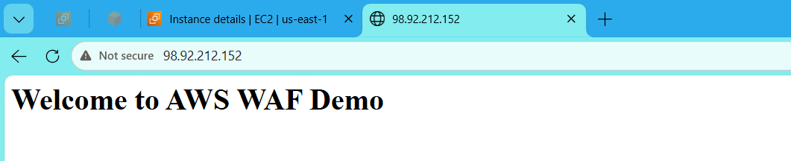

Step 2: Create a Target Group
Go to:
EC2 → Target Groups → Create Target Group
- Target type: Instances
- Protocol: HTTP
- Port: 80
- Name: WAF-TargetGroup
Register the EC2 instance.
Screenshot: Target Group.
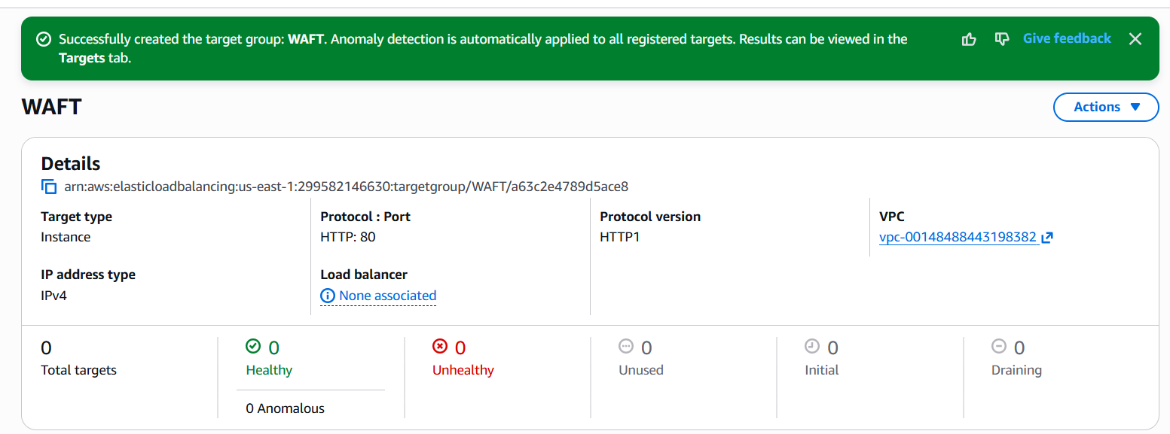
Step 3: Create an Application Load Balancer
Go to:
EC2 → Load Balancers → Create Application Load Balancer
Configure:
- Name: WAF-ALB
- Scheme: Internet-facing
- Listener: HTTP (80)
- Select at least 2 subnets
- Security Group: Allow HTTP
- Target Group: WAF-TargetGroup
Create the ALB.
Wait until the status becomes Active.
Screenshot: ALB Dashboard.
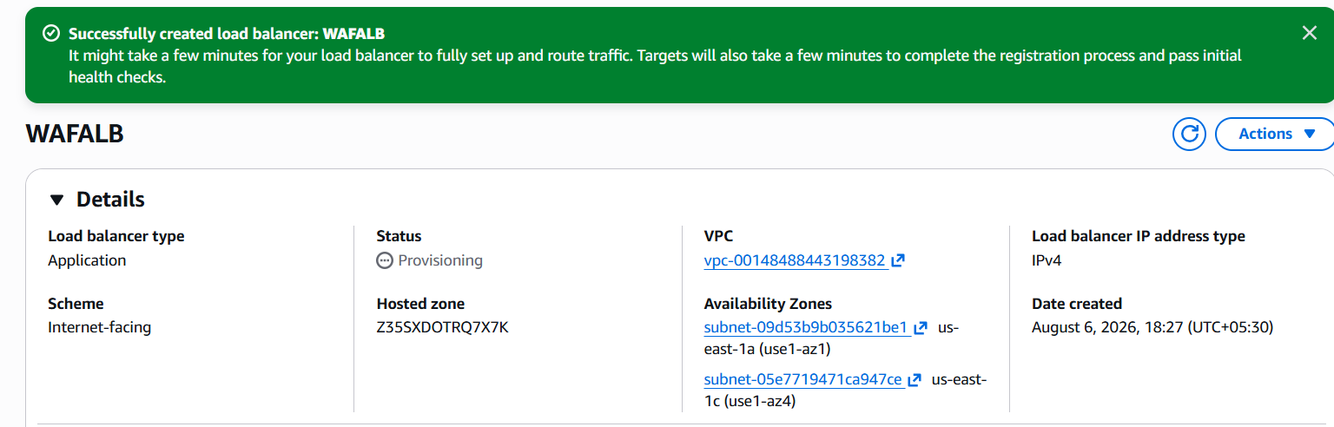

Step 4: Verify ALB
Open the ALB DNS name:
http://<ALB-DNS-Name>
Expected output:
Welcome to AWS WAF Demo
Screenshot: Website through ALB.
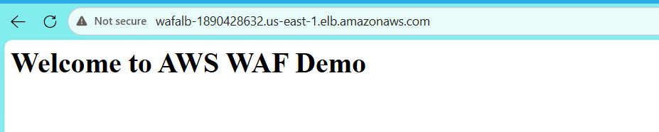

Step 5: Create AWS WAF Web ACL
Go to:
AWS WAF → Create Web ACL
Configure:
Field | Value
Name | Demo-WebACL
Scope | Regional
Resource | Application Load Balancer
Associated Resource | WAF-ALB
Click Next.
Screenshot: Web ACL Configuration.
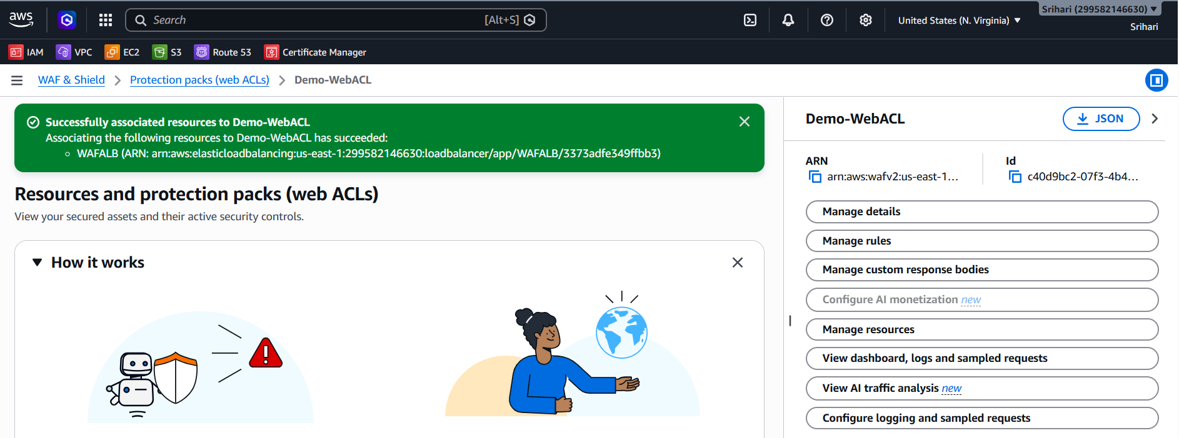

Step 6: Add Managed Rules
Click:
Add Rules → Add Managed Rule Groups
Select:
- AWS Managed Rules
- AWSManagedRulesCommonRuleSet
Click Next.
Screenshot: Managed Rules. 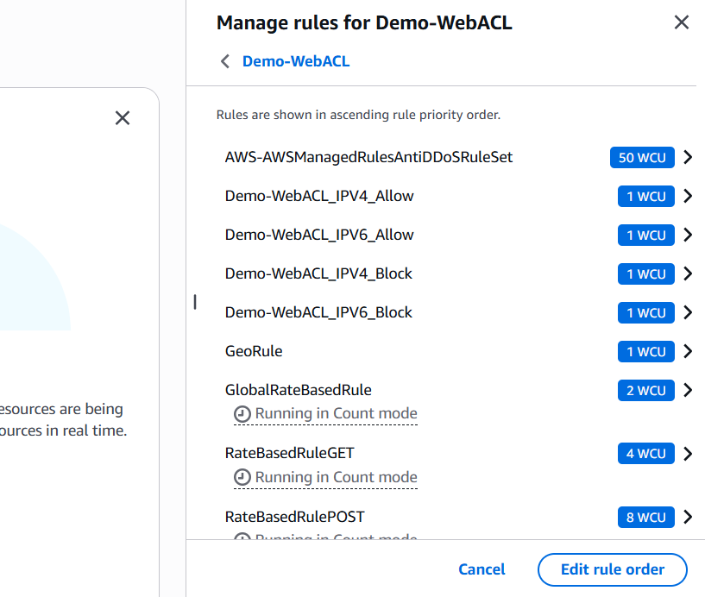

Step 7: Create the Web ACL
Review the configuration.
Click Create Web ACL.
Wait until the status is Ready.
Screenshot: Web ACL Created.
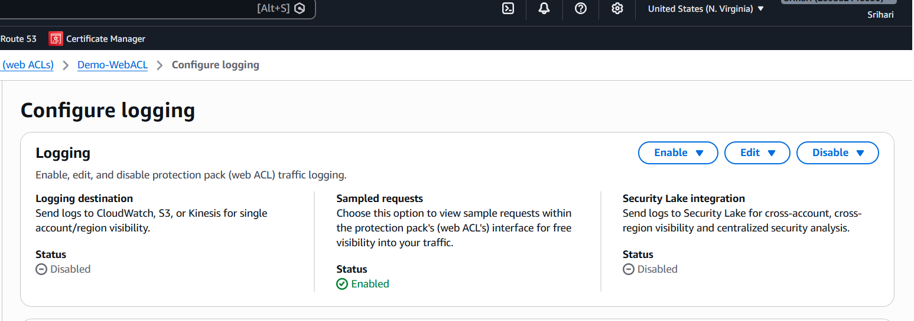

Step 8: Test the Website
Open:
http://<ALB-DNS-Name>
The page should display:
Welcome to AWS WAF Demo
This confirms the request is flowing through AWS WAF to the ALB and then to the EC2 instance.

Step 9 (Optional): Test a Malicious Request
In your browser, try:
http://<ALB-DNS-Name>/?id=%27%20OR%201%3D1%20--
If the request matches the enabled SQL injection managed rules, AWS WAF may block it and return 403 Forbidden.
Note: Because the backend is a simple Apache page (not a real database-driven application), this test may not always produce a block. The important part is that WAF inspects the request before forwarding it.

2. To securely store and manage configuration values and application parameters using AWS Systems Manager Parameter Store.

Step 1: Open Parameter Store
Go to
AWS Console
→ Systems Manager
→ Parameter Store
→ Create parameter
Screenshot: Parameter Store Dashboard
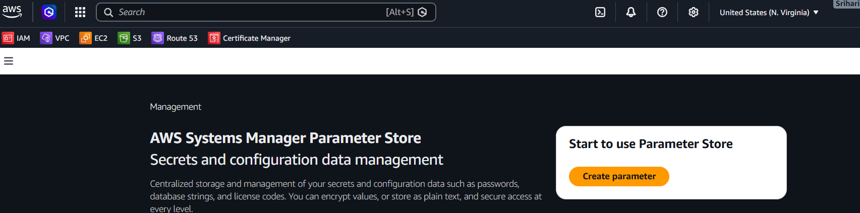
Step 2: Create Database Host Parameter
Fill:
Field | Value
Name | /prod/database/host
Type | String
Value | mysql.company.com
Click Create parameter
Screenshot
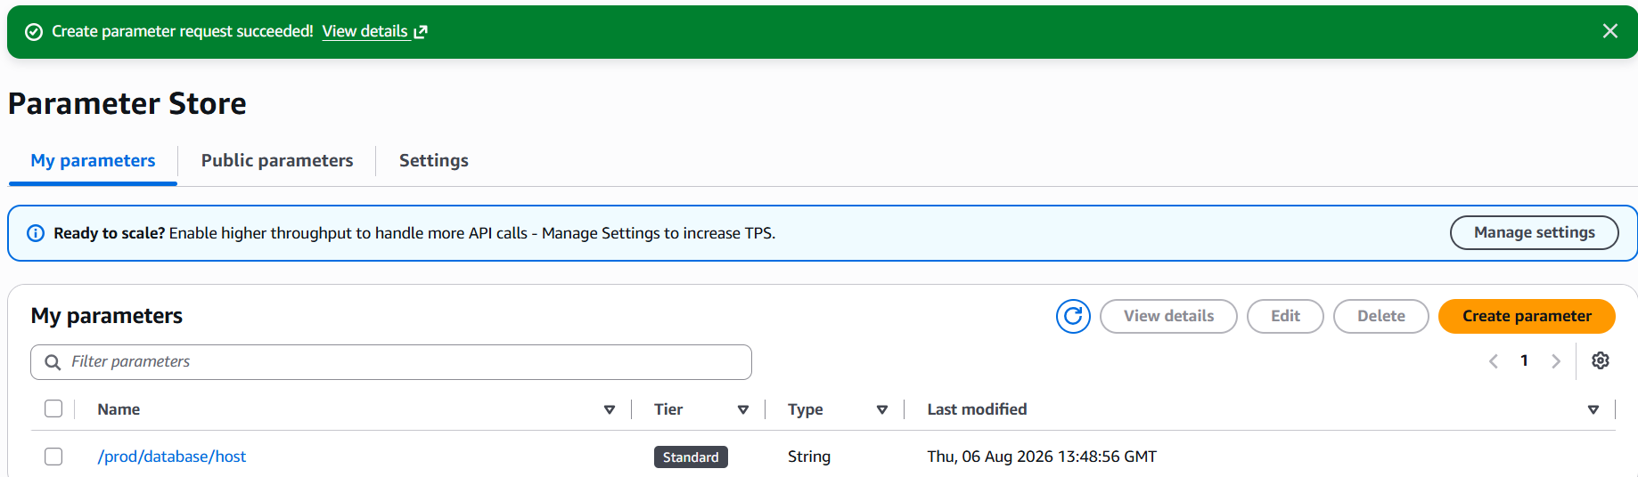

Step 3: Create Database Username
Name:
/prod/database/username
Type:
String
Value:
admin
Click Create.
Screenshot
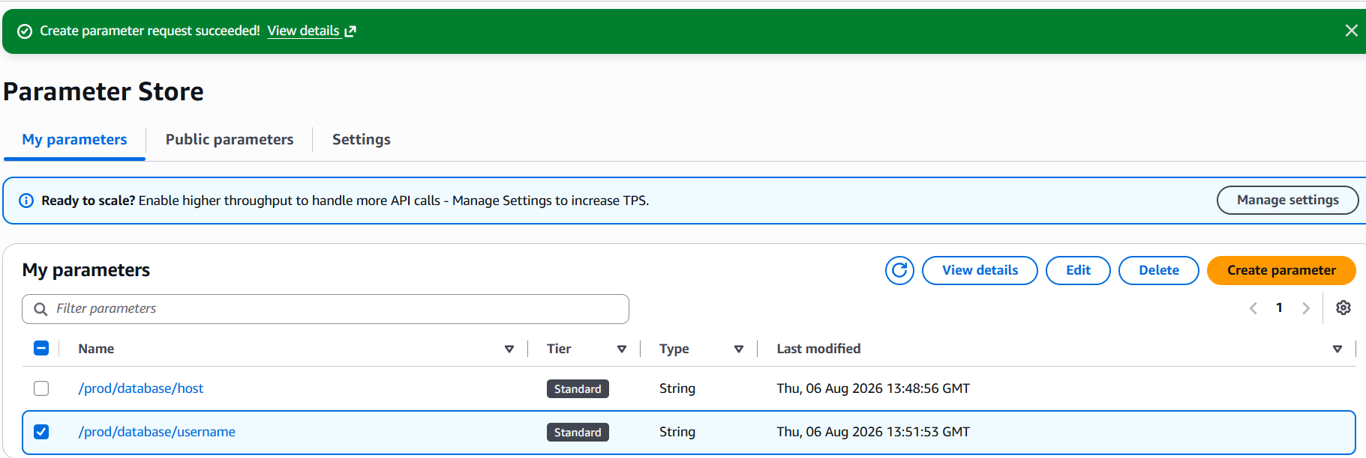

Step 4: Create Database Password
Click Create Parameter
Fill
Name:
/prod/database/password
Type:
SecureString
KMS Key:
aws/ssm
Value:
Password@123
Click Create
Screenshot
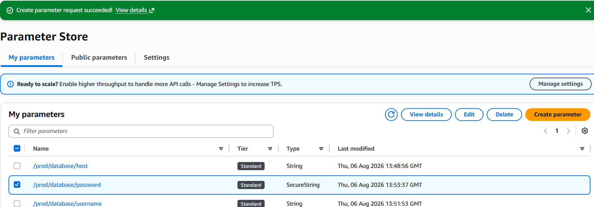

Step 5: Verify
Now Parameter Store contains
/prod/database/host
/prod/database/username
/prod/database/password
The password will appear encrypted because it is stored as a SecureString.
Screenshot
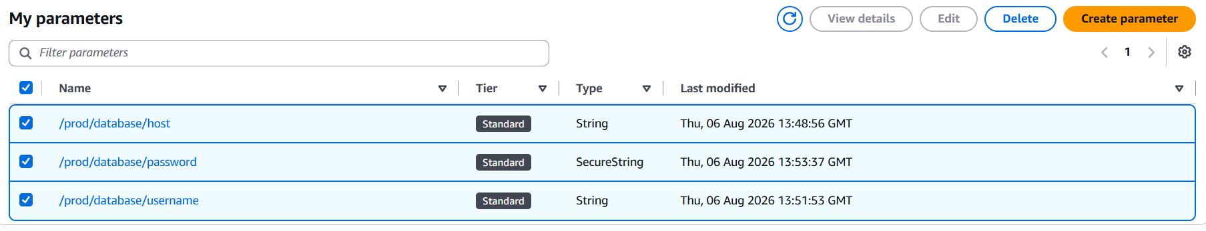
Step 6: Retrieve Parameters from EC2
Launch an EC2 instance with an IAM role that has the AmazonSSMManagedInstanceCore policy attached.
Step 1: Create an IAM Role
Go to:
AWS Console
→ IAM
→ Roles
→ Create role
Choose:
Trusted entity:
AWS Service
Click Next.

Step 2: Select Use Case
Choose:
EC2
Click Next. 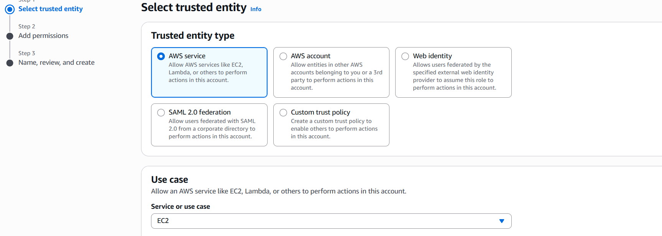
Step 3: Attach Policy
Search for:
AmazonSSMManagedInstanceCore
Check the box.
This policy allows the EC2 instance to communicate with AWS Systems Manager.
Click Next.
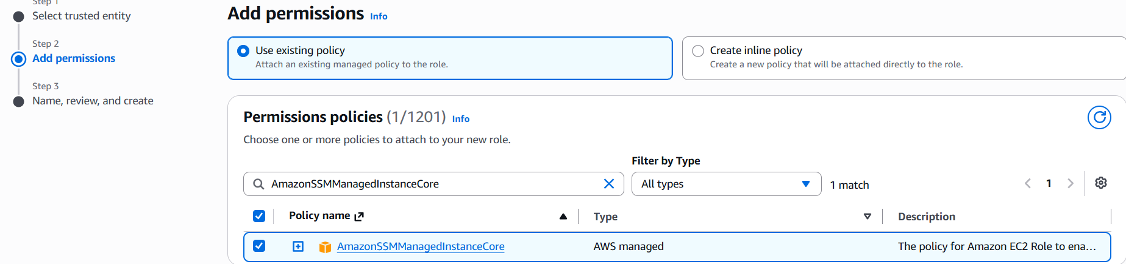
Step 4: Name the Role
Example:
EC2-SSM-Role
Click Create role.
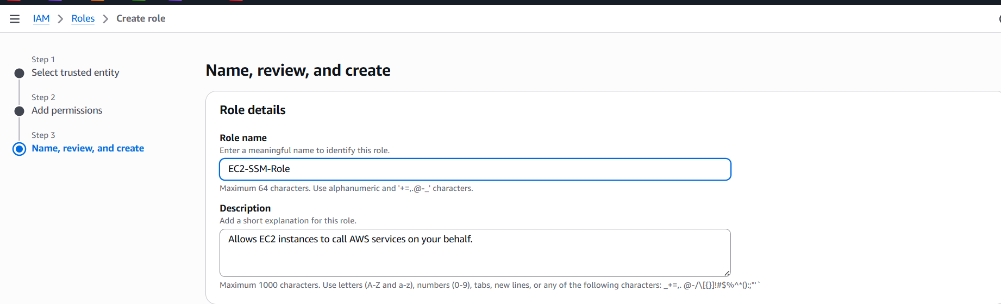
Step 5: Launch an EC2 Instance
Go to:
EC2
→ Instances
→ Launch Instance
Fill in:
Setting | Value
Name | ParameterStore-EC2
AMI | Amazon Linux 2023 (or Amazon Linux 2)
Instance Type | t2.micro
Key Pair | Select your existing key pair
Security Group | Allow SSH (22) from your IP

Step 6: Attach the IAM Role
Scroll down to the Advanced details section.
Find:
IAM instance profile
Select:
EC2-SSM-Role
Screenshot: IAM Role attached to EC2
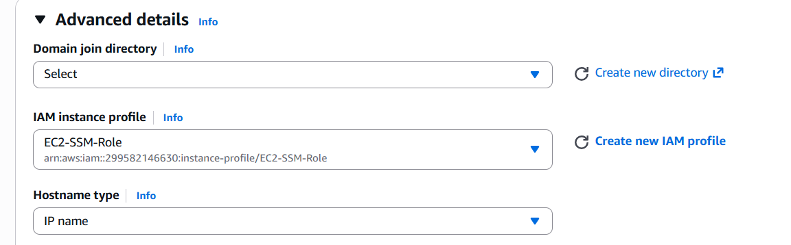

Step 7: Launch the Instance
Click:
Launch Instance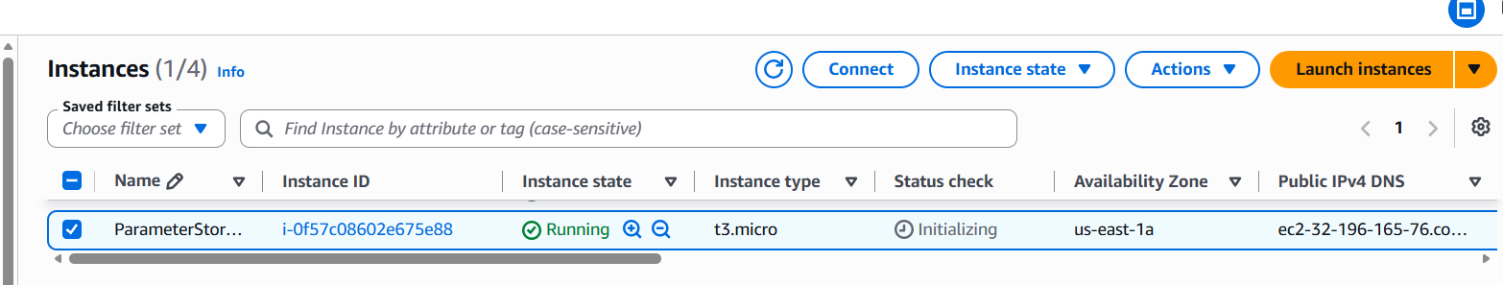

Step 8: Connect to EC2
ssh -i mykey.pem ec2-user@<Public-IP>

Run:
aws ssm get-parameter \
--name "/prod/database/host"
Output:
mysql.company.com
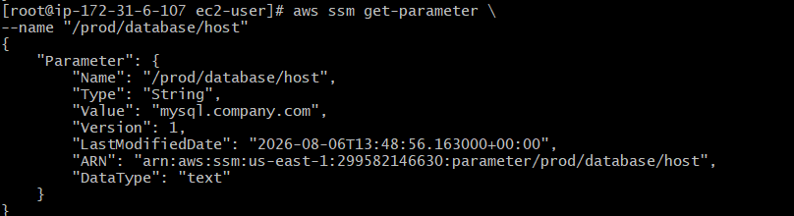
Retrieve the password:
aws ssm get-parameter \
--name "/prod/database/password" \
--with-decryption
Output:
Password@123
